New-Dis-Eur-Sweden-Runes-Rök Runestone--9th century

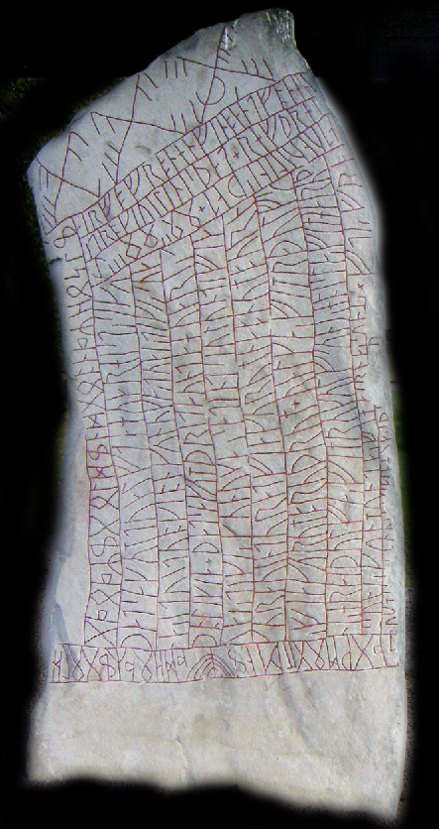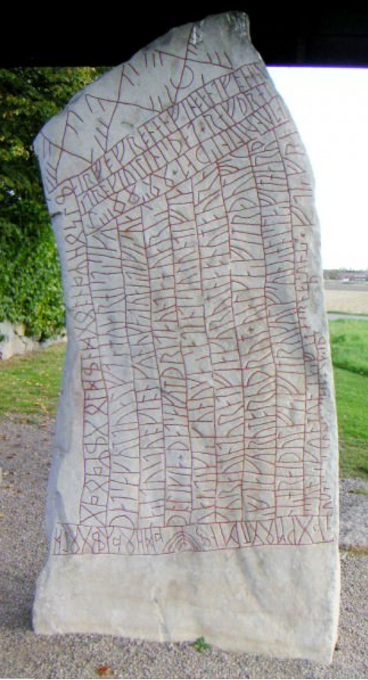

An inscription using cipher runes, the Elder [Futhark](http://www.ancient.eu/Futhark/), and the Younger Futhark, on the 9th-century Rök Runestone in Sweden.